Nicholas Alpine, Tristan Casey, Aman Rauniyar

student grade tracker

**Table of Contents**

**Introduction** 2

**Abstract** 2

**UML Diagram** 3

**Plan for Classes and Functions** 3 - 4

**Future Ideas** 4

**References** 4

**Introduction**

During our time learning the C++ programming language, we have learned many techniques that can help us to create a full-fledged project to present at the end of the semester. Classes are used to initialize the variable and headers of functions that will be used and can be made to either be used exclusively for the class (private) or allowed to be used by other classes (public). Functions are the building blocks that help to perform different tasks throughout the program and to increase modulization. Vectors can be used over arrays in order to create a list that can changes increase or decrease its maximum size even after the beginning of runtime. Using these concepts, we will create a project that shows how much we have learned throughout the semester.

**Abstract**

The goal of our project is to make a grade-tracking program using the C/C++ programming language. Some of the ideas we would like to implement include allowing the user to input grades for students, storing a student’s grade using a database, automatically having the program calculate each student’s GPA based on the information entered by the user, and to output reports that display certain personal information about the student (such as their full name, age, education level, etc.) and relevant grade information (grade for each class using both percent and letter scores, their current GPA, etc.).

**UML Diagram**

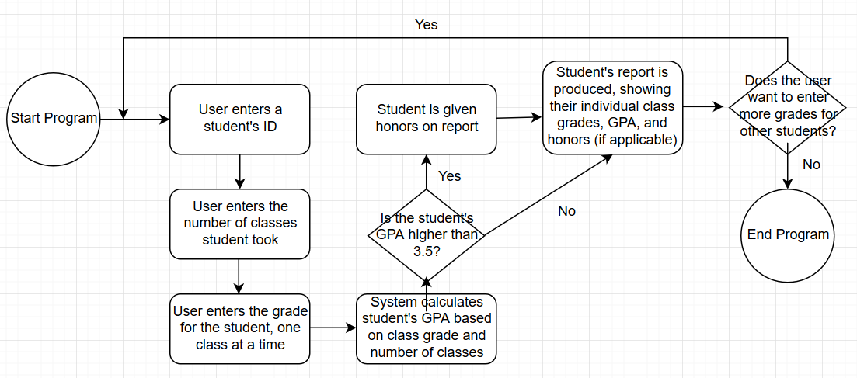

**Plan for Classes and Functions**

GradeTrackingSystem.h File

Course Structure: Contains variables for the course ID, course name, the amount of credits the course offers, and the grade the student has earned in the course.

Student Class: Contains variables for the student ID, student’s first name, student’s last name, and the vector holding the courses a student has taken. Also contains the headers for the functions used in the GradeTrackingSystem.cpp file.

GradeTracker.cpp File

Main Class: Used to run the program.

Example Function: Used to test the code by sending predetermined values to the Student Class.

GradeTrackingSystem.cpp File

printAllCourses Function: If the course vector is empty, the system tells the user that no courses have been added. Otherwise information about every course the student has taken is displayed by calling the printCourse function.

printCourse Function: Used to format the information for each course and is called by other functions.

findCourse Function: Used to iterate through the course vector until the chosen is either located or isn’t found and is called by other functions.

addCourse Function: Pushes back the course vector to make room for another course.

removeCourse Function: Calls the findCourse function to iterate through the course vector and if the requested course isn’t found in the vector the system tells the user the course wasn’t found. Otherwise the chosen course is removed at the index.

**Future Ideas**

Some possible features that could be implemented in the future:

* The ability to track the grades of multiple students at once.
* The ability for students to choose courses from a list and add them to the grade tracker.
* The ability to save and load student data to a file instead of being deleted after the program closes.

**References**

<https://github.com/> (for sharing the code between team members)

<https://stackoverflow.com/> (for help on proper syntax in certain parts of the project)